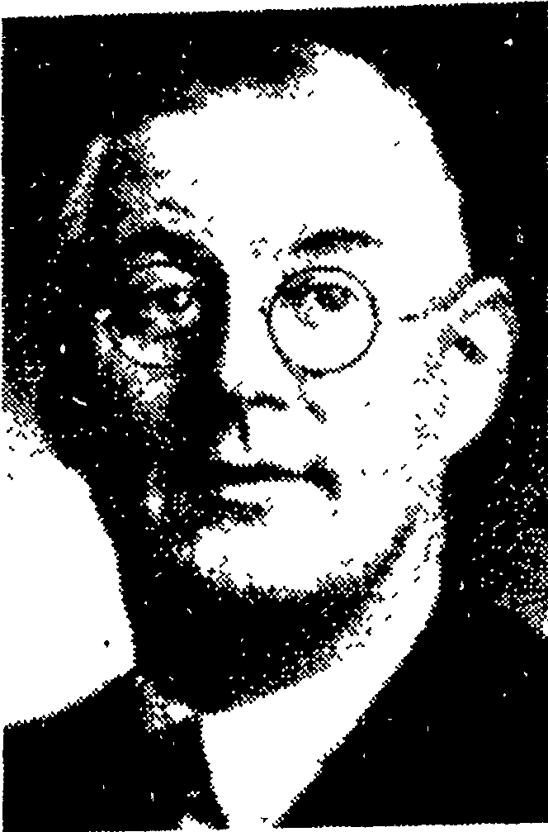
In September 2017, Jane Knox-Hyder called Kāpiti Coast District Libraries with information regarding Raumati South Street names – Leinster Ave and Sydney Crescent. Leinster Ave was part of a sub-division developed by Sydney Hyder (formerly of Wellington) who moved to the area when he retired. He was a former president of the Faculty of Insurance. Mrs Knox-Hyder does not believe that Arthur Hyder farmed the land – as stated in the Kapiti Historical Society information held by Kāpiti Coast District Libraries.
Sydney Crescent is named after Arthur Hyder’s son, Sydney. Sydney was POW during World War Two. He later married and had two children. Mrs Knox-Hyder is his daughter-in-law. In some published resources it has been recorded that Sydney Hyder died during World War Two – this information is incorrect.
Source: Jane Knox-Hyder, September 2017

