Bi-Lingual road sign in Otaki
Friday, 24 August 2007, 3:42 pm
Press Release: Kapiti Coast District Council

Bi-Lingual road sign in Otaki
In what is believed to be a first for New Zealand, a new street in Otaki has an English and Chinese name to celebrate the multicultural and multilingual status of the town and its history.
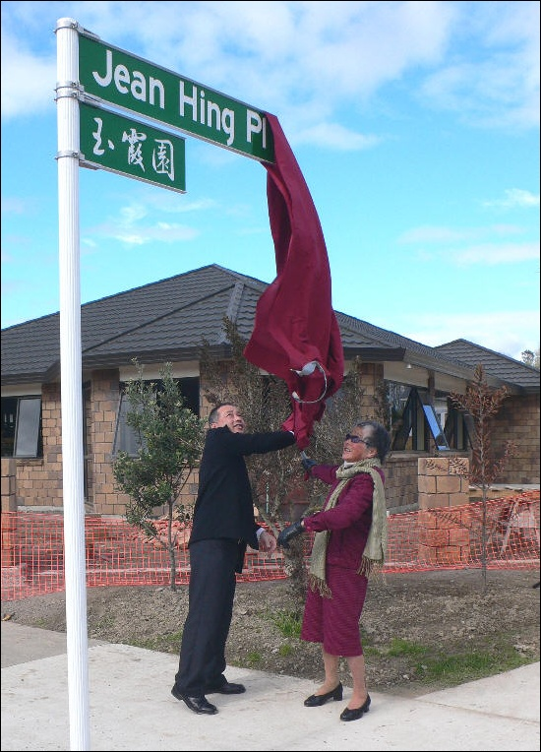
Jean Hing and son Robert Young unveil the first Chinese road sign
Jean Hing Place commemorates the enormous contribution made by the Chinese community to Otaki over more than 80 years and celebrates one of the district’s oldest Chinese families.
On the Kapiti Coast and Otaki in particular considerable effort goes into ensuring that street names reflect the history and settlement of the area they are in.
Bilingualism is part of the Otaki community’s Greater Otaki Vision, and this new sign is one step in making that vision a reality, the Mayor of Kapiti Coast, Alan Milne said.
A large invited audience gathered at the sign earlier this week to see it unveiled by Jean Young (nee Hing) herself and by her youngest son Robert Young.
ENDS

